21.92: a)
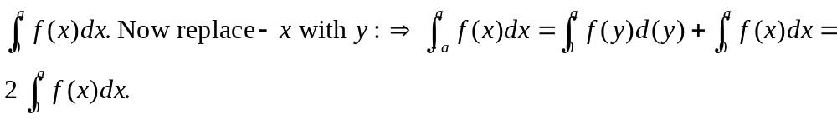
b)

c) The integrand in 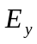 for Example 21.11 is odd, so =0.

